# Angular

**Materials and resources:**

<https://angular.io/docs>

<https://cli.angular.io/>

<https://www.dunebook.com/from-zero-to-hero-learn-angularstrap-from-scratch/>

<http://www.netinstructions.com/100-days-of-angular-2/?utm_source=mybridge&utm_medium=web&utm_campaign=read_more>

<https://github.com/johnpapa/angular-styleguide/blob/master/a2/README.md>

<https://legacy.gitbook.com/book/basarat/typescript/details>

<https://basarat.gitbooks.io/typescript/>

<https://www.youtube.com/watch?v=qRD7bkK7m10>

<https://thinkster.io/tutorials/learn-angular-2>

<https://www.tutorialspoint.com/angular2/>

Books: ng-book2-r37

## Assignments:

Task 1: Implement ‘Portal: Product list page’

On the main page on the Portal, the user can view, search products and add products to the card. On very top on the page have a search bar. When the user enters some keyword in the input field and clicks on ‘Search’ button, cards that only contains searched keyword ale listed. Products can be searched by ‘Name’. Bellow ‘Search’ bar all categories and subcategories are listed. On click on some category or subcategory, all items that are in that category or subcategory are listed. When the user clicks on image or title from the card, the user is redirected on ‘Product view page’. When the user clicks on ‘Add to card’ product is added to the card and number of products indicator is changed.

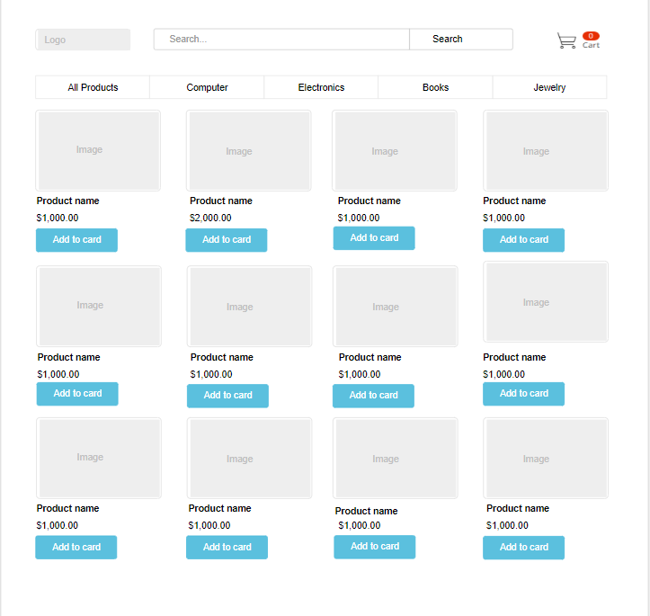

Portal: Product list page